IALD Presents an Award of Excellence for the Crown Fountain
Schuler Shook Accepts Award
New York, NY, April 13, 2005 – At its 22nd Annual IALD Awards Presentation, the International Association of Lighting Designers (IALD) is pleased to present an Award of Excellence for the Crown Fountain, a focal point in a public park in Chicago, Illinois. The entry was judged in the monumental structures/public spaces category. This year, seven projects earned awards of excellence, and three were in the monumental structures/public spaces category. Principal lighting designer on the project is Jim Baney, IALD, of Schuler Shook, also in Chicago, Illinois. Other lighting designers credited on the project are Autumn Metzler and Brian Garthwaite.
 | 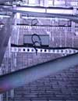 | 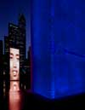
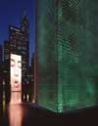 | 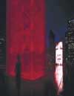 | 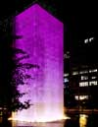 | 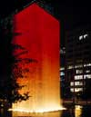 | 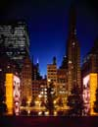
Crown Fountain anchors one corner of Chicago’s new Millennium Park. Here, two 50-foot glass towers are connected by a shallow reflecting pool. Each tower portrays the faces of Chicagoans and changes with random programmed sequences. When the video image purses its mouth, a fountain of water emerges. Grazing fixtures, mounted below a stainless steel grate at the base of the towers, illuminate the spout of water. The sequences also allow both color-changing interior fixtures and the exterior fixtures to be on at the same time creating a gradient from white grazing to a colored interior glow.
“The effect is just exquisite,” remarked one judge.
At this year’s 22nd annual event, the IALD awarded 23 projects that represented six of the seven categories. Seven IALD Awards of Excellence were awarded: one in both the corporate and retail categories; two in site/façade; and three in the category of monumental structures/public spaces. The highest point earner wins the Radiance Award for Excellence in Architectural Lighting Design. Fifteen projects earned IALD Awards of Merit, two in both the hospitality and corporate categories, three in the site/façade category, and four in each the retail/entertainment and monumental structures/public spaces categories. An IALD Special Citation for innovative use of materials and techniques for daylighting control was granted for an entry in the academic/institutional category.
The IALD Lighting Design Awards program, established in 1983 and co-sponsored by Professional Lighting Design magazine, honors lighting projects that display high aesthetic achievement backed by technical expertise. Entries are submitted into one of seven categories: Academic/Institutional; Corporate; Hospitality; Monumental Structures/Public Spaces; Residential; Retail/Entertainment; and Site/Façade. Additionally, projects can also be submitted for consideration in the sustainable design award category, which means the project undergoes an additional round of judging keyed solely to the fulfillment of sustainable design principles. A panel of award-winning lighting designers and architects review the projects.
This year, the IALD received 141 submissions from 14 countries. The IALD, established in 1969, is an international organization dedicated to the profession of architectural lighting design. Based in Chicago and comprised of 700 members throughout North and South America, Europe, Asia and Australia, the IALD’s role is to set the global standard for lighting design excellence.
Additional information can be downloaded from

